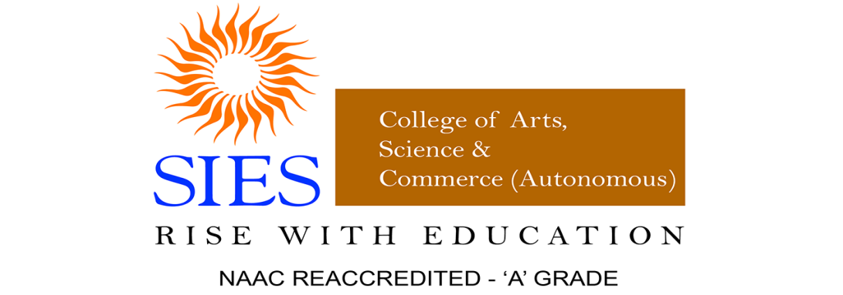
The Department of Mass Media
Seminar Report on Career Guidance Series [Part - 3]
Title of the Session: Advertising as a Socially Challenging Career
Day & Date and Time: 3rd June 2021, Thursday, 10:00 am -11:30 am
Background:
The Department of Mass Media organised a Career Guidance Series for Mass Media enthusiasts facilitated by Mr. Akash Purswani.

Seminar Objectives:
- To study the various facets of Advertising
- To impart knowledge on the career opportunities in Advertising
- To identify the social challenges in Advertising Industry
Location: Online: Microsoft Teams Learning Management System
Registrations done by: 43 prospective TYBAMMC
Target Audience and Participation: 26 prospective TYBAMMC
Session and name of Resource Person: Online by Mr. Akash Purswani
Details of the session: The Department of Mass Media organised a Career Guidance Series on 3rd June 2022 for Advertising students facilitated by Mr. Akash Purswani for media mavens.
- The interactive session commenced with an introductory session; wherein Mr. Akash Purwani shared his knowledge and experience in the field of Advertising.
- He explained about the various types of Advertising agencies and its working.
- Mr. Akash concluded the session by talking about the career opportunities in the field of Advertising and the social challenges faced in the advertising industry.

Outcome:
The feedback of participants reflects the following points satisfactorily such as
- identifying the career opportunities in Advertising;
- in understanding various aspects of Advertising
- in dealing with the social challenges in Advertising

Funding if any: Nil
Annexures:
- List of Participants: prospective students of
SYBAMMC 2021-22 who shall seek admission in TY in 2022-23

Meeting Summary
Total Number of Participants | 26
Meeting Title | General
Meeting Start Time | 6/3/2021, 10:21:52 AM
Meeting End Time | 6/3/2021, 12:37:18 PM
Full Name | Join Time | Leave Time | Duration | Email | Role
Vaneeta Raney | 6/3/2021, 10:21:52 AM | 6/3/2021, 12:37:18 PM | 2h 15m | vaneetar@sies.edu.in | Organizer
ahaan shetty | 6/3/2021, 10:27:15 AM | 6/3/2021, 11:38:38 AM | 1h 11m | ahaans41372@ascs.sies.edu.in | Attendee
Vanasri Sridhar | 6/3/2021, 10:27:35 AM | 6/3/2021, 12:15:29 PM | 1h 47m | vanasris8500@ascs.sies.edu.in | Attendee
Harsh Rane | 6/3/2021, 10:29:13 AM | 6/3/2021, 12:17:24 PM | 1h 48m | harshr41772@ascs.sies.edu.in | Attendee
Smrithi Arun | 6/3/2021, 10:29:55 AM | 6/3/2021, 12:37:02 PM | 2h 7m | smrithia22275@ascs.sies.edu.in | Attendee
Isha Thakur | 6/3/2021, 10:29:58 AM | 6/3/2021, 12:15:18 PM | 1h 45m | ishat42824@ascs.sies.edu.in | Attendee
Akash Purswani | 6/3/2021, 10:30:09 AM | 6/3/2021, 12:15:33 PM | 1h 45m | akash@ce.sies.edu.in | Presenter
Jaanvi Anil Rambade | 6/3/2021, 10:30:27 AM | 6/3/2021, 12:14:34 PM | 1h 44m | jaanvir43426@ascs.sies.edu.in | Attendee
Dhanashree Shreedhar Pai | 6/3/2021, 10:32:34 AM | 6/3/2021, 12:14:33 PM | 1h 41m | dhanashreep40632@ascs.sies.edu.in | Attendee
bhavikad41514 | 6/3/2021, 10:32:43 AM | 6/3/2021, 11:18:44 AM | 46m 1s | bhavikad41514@ascs.sies.edu.in | Attendee
bhavikad41514 | 6/3/2021, 11:20:20 AM | 6/3/2021, 12:14:49 PM | 54m 28s | bhavikad41514@ascs.sies.edu.in | Attendee
Aditi Shevade | 6/3/2021, 10:32:51 AM | 6/3/2021, 12:15:18 PM | 1h 42m | aditis14525@ascs.sies.edu.in | Attendee
Sakshi Ubale | 6/3/2021, 10:33:16 AM | 6/3/2021, 12:15:27 PM | 1h 42m | sakshiu11415@ascs.sies.edu.in | Attendee
Radhni Nimbkar | 6/3/2021, 10:34:22 AM | 6/3/2021, 11:37:57 AM | 1h 3m | radhnin40391@ascs.sies.edu.in | Attendee
Radhni Nimbkar | 6/3/2021, 11:43:38 AM | 6/3/2021, 12:15:30 PM | 31m 52s | radhnin40391@ascs.sies.edu.in | Attendee
Shubham Dhuri | 6/3/2021, 10:34:43 AM | 6/3/2021, 11:25:37 AM | 50m 53s | shubhamd11921@ascs.sies.edu.in | Attendee
Shubham Dhuri | 6/3/2021, 11:27:52 AM | 6/3/2021, 12:14:56 PM | 47m 3s | shubhamd11921@ascs.sies.edu.in | Attendee
Aaryaa Santhosh Kumar | 6/3/2021, 10:35:09 AM | 6/3/2021, 12:14:35 PM | 1h 39m | aaryaas40129@ascs.sies.edu.in | Attendee
Jason Lopez | 6/3/2021, 10:36:19 AM | 6/3/2021, 10:41:11 AM | 4m 52s | jasonl41421@ascs.sies.edu.in | Attendee
Kavya Pillai | 6/3/2021, 10:36:46 AM | 6/3/2021, 12:15:27 PM | 1h 38m | kavyap8563@ascs.sies.edu.in | Attendee
Arunima Bengeri | 6/3/2021, 10:37:06 AM | 6/3/2021, 12:14:35 PM | 1h 37m | arunimab42499@ascs.sies.edu.in | Attendee
Shreyas Chavanke | 6/3/2021, 10:38:02 AM | 6/3/2021, 12:15:31 PM | 1h 37m | shreyasc42443@ascs.sies.edu.in | Attendee
Janhavi Pathak | 6/3/2021, 10:42:17 AM | 6/3/2021, 12:14:35 PM | 1h 32m | janhavip11577@ascs.sies.edu.in | Attendee
Sneha Santosh Iyer | 6/3/2021, 10:49:44 AM | 6/3/2021, 10:55:47 AM | 6m 3s | snehai39992@ascs.sies.edu.in | Attendee
Sneha Santosh Iyer | 6/3/2021, 11:01:12 AM | 6/3/2021, 11:36:44 AM | 35m 32s | snehai39992@ascs.sies.edu.in | Attendee
avirat shanbhag | 6/3/2021, 10:50:39 AM | 6/3/2021, 11:07:12 AM | 16m 32s | avirat8501@ascs.sies.edu.in | Attendee
Brahmi Ghadigaonkar | 6/3/2021, 10:53:39 AM | 6/3/2021, 11:14:27 AM | 20m 47s | brahmig42519@ascs.sies.edu.in | Attendee
Brahmi Ghadigaonkar | 6/3/2021, 11:16:18 AM | 6/3/2021, 11:36:53 AM | 20m 34s | brahmig42519@ascs.sies.edu.in | Attendee
Sameeksha Shetty | 6/3/2021, 10:57:54 AM | 6/3/2021, 11:48:05 AM | 50m 11s | sameekshas41006@ascs.sies.edu.in | Attendee
Archana Jaishankar | 6/3/2021, 11:00:04 AM | 6/3/2021, 12:15:11 PM | 1h 15m | archanaj43538@ascs.sies.edu.in | Attendee
Shravani Madhukar Hulavane | 6/3/2021, 11:07:56 AM | 6/3/2021, 11:27:58 AM | 20m 2s | shravanih41388@ascs.sies.edu.in | Attendee

2. Poster:

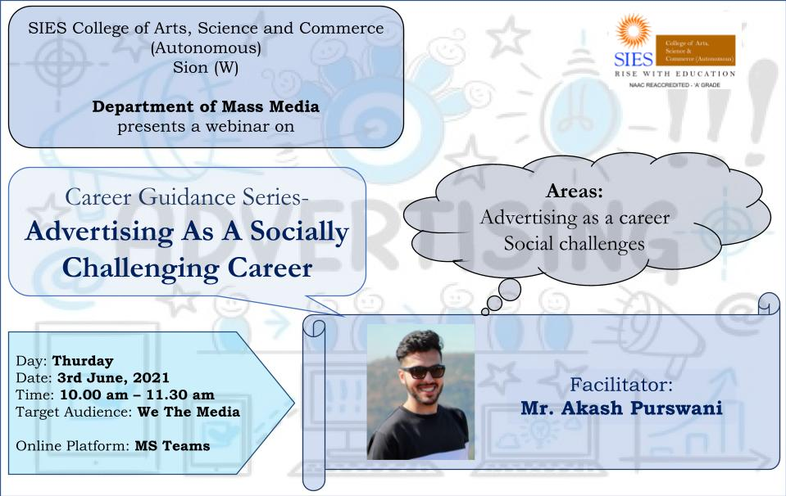
Report Prepared by: Dr. Vaneeta Raney
Course Coordinator,
Department of Mass Media

